H.T No
Regulations:
A17

Sreenidhi Institute of Science and Technology
(An Autonomous Institution)
Code No: 6FC34 Date: 07-Dec-2020 (FN)

B.Tech III-Year II-Semester External Examination, Nov/Dec - 2020 (Regular)
AUTOMATA AND COMPLIER DESIGN (IT)

Time: 2 Hours Max.Marks:75

Note: a) No additional answer sheets will be provided.
b) All sub-parts of a question must be answered at one place only, otherwise it will not be valued.
c) Missing data can be assumed suitably.

ANSWER ANY 5 OUT OF 8 QUESTIONS. EACH QUESTION CARRIES 15 MARKS.

1. | a) | Explain in detail about the process of converting finite automata into regular expressions. | [8M]
 | b) | Analyze the strategy of converting NFA to DFA with a suitable illustration. | [7M]
2. | a) | Convert the following grammar to Greibach Normal Form (GNF).  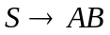  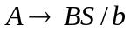  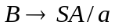 | [8M]
 | b) | Identify an equivalent grammar in Chomsky Normal Form (CNF) for the productions  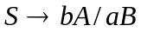  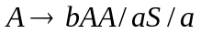  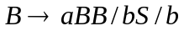 | [7M]
3. | a) | Identify the process of operations of the compiler which transforms the source program from one representation into another. Illustrate the output to the input.  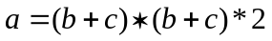 | [8M]
 | b) | Summarize the complete steps involved in the process of LL(1) parsing with suitable example. | [7M]
4. | a) | Generate a syntax-directed translation scheme that translates arithmetic expressions from infix to postfix notation. | [8M]
 | b) | Show that the following grammar  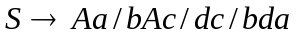  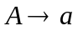  Is LALR(1) but not SLR(1). | [7M]
5. | a) | Outline the significance of 3-address statements. | [8M]
 | b) | Describe different runtime storage management schemes with their potentialities. | [7M]
6. | a) | Discuss in detail about the process of peephole optimization. | [8M]
 | b) | Recall the complete steps that are inherent with the DAG representation of basic blocks. | [7M]
7. | a) | Develop the process of converting an NFA with Є-moves to NFA without Є-moves. | [8M]
 | b) | Compare and contrast between Moore and Mealy machine with an example. | [7M]
8. | a) | Examine the equivalences of CFLs and PDAs with an appropriate example. | [8M]
 | b) | Relate the role of rightmost derivation and leftmost derivation associated in verifying the ambiguity of a Context Free Grammar. | [7M]
-- 00 -- 00 –

